31.45: 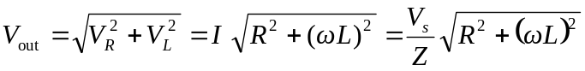
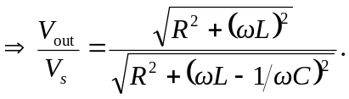
It is small: 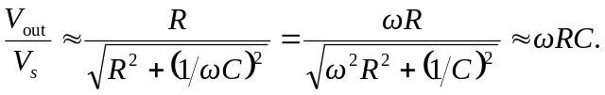
If is large: 